**SOFTWARE REQUIREMENT SPECIFICATION**



**SRM System**

**HIT Team**

Consulting

Sales

Staffing

Support

# Information of document

|  |  |
| --- | --- |
| **Title** | **Software Requirement Specification** |
| **Author(s)** | All team |
| **Reviewer(s)** | All team |
| **Team name** | HIT Team |
| **Team members** | Thanh Giang, Hiep Ta, Phuc Nguyen, Giang Nguyen, Dat Tran, Huy Huynh |
| **Project mentors** | Ms. Huong Nguyen, Mr. Huyen Pham |
| **Editor** |  |
| **Type of report** | Software Requiremen tSpecification |
| **Software used** | MS Word |

# Document Reviewer Information

|  |  |  |
| --- | --- | --- |
| Reviewer Name | Review Attendance (R/S) | Comments |
|  |  |  |
|  |  |  |
|  |  |  |

# Document Approver Information

|  |  |  |
| --- | --- | --- |
| Approver Name | Approver Function | Comments |
|  |  |  |
|  |  |  |
|  |  |  |

# Document Revision History

|  |  |  |  |  |
| --- | --- | --- | --- | --- |
| Date | Revision | Status | Change Summary | Revised by |
| 28/5/2012 | 1.0 |  | Write SRS Draft | Thanh Giang |
| 8/6/2012 | 1.0 |  | Update Static Perspective | Huy Huynh |
|  |  |  |  |  |
|  |  |  |  |  |

Table of Contents

Information of document 2

Document Reviewer Information 2

Document Approver Information 2

Document Revision History 2

Table of Contents 3

1. Introduction 4

1.1 Purpose 4

1.2 Document Conventions 4

1.3 Intended Audience and Reading Suggestions 5

1.4 Project Background and Scope 5

1.4.1 Background 5

1.4.2 Scope 5

1.5 References 6

2. Overall Description 6

2.1 Product Perspective 6

2.1.1 Physics 6

2.1.2 Static Perspective 8

2.1.3 Dynamic Perspective 8

2.2 Product Features 10

2.3 User classes and characteristics 11

2.4 Operating Environment 11

2.5 Design and implement constraints 12

2.6 User Documentation 12

3. System Features 12

-- The End -- 14

# Introduction

## Purpose

Base on the needs of student information’s management for Van Lang University, HIT Team shall provide to all customers SRM (Student Record Management) product - an advanced tool to manage student records

The SRS enumerates the deliverables and services to be provided by The Hit Team to the client, describe overview the system and detail functional and also non-functional of the SMS System. Although a signature page accompanies the document, the SRS is not a legal contract. Its intent is to level-set expectations and to build understanding of the process that the team will follow while creating deliverables.

## Document Conventions

This SRS document is written for developers to read and implement. The SRS document includes computer terms, software terms, and technical terms…Written style most likely for officer of faculty or department, administrator of this system.

Typographical Convention

|  |  |
| --- | --- |
| Typographic | Reading/Understanding Convention |
| SRM system | This term stands for Student Resource Management system |
| Highlighting words/sentences | Main/key ideas of whole paragraph or a section |
| Bold/Italic/Underline words | Information/Data must be paid attention on |
| Table Color | Distinguish different objects/ideas |
| <> | Reference |

## Intended Audience and Reading Suggestions

|  |  |
| --- | --- |
| Intended Audience | Reading Suggestions |
| Project Manager | Section 3 – System Features: Describe functions in details and constrains to make the Project Manager has an overview. So he can have the estimates for the project. |
| Software Architecture and Designer | Appendix 2: This section describes Use-case diagram and Use-case descriptions. It makes easily to design and develop the proposed system. |
| Tester | The Overview section and Use case: they will help to make the test plan and write the acceptance test |

## Project Background and Scope

## Background

Van Lang University (VLU) is facing with an urgent problem in the management of student records because the number of students is increasing. VLU was founded 15 years and has 15 Faculty / Department training distributed in two facilities. The total student population of about 12,000 students and university receives about 3,000 students yearly

Difficulties:

## When start the school year, VLU have to hire many external employees to input record in several days so the operation is done manually so it very difficult and consume time

## Faculties/ Departments cannot report the number of record received during the day, statistical reports must wait until the record receiving process end.

## Process using tools such as paper documents, Excel file, Word file to the manage records of all students will make it hard to search later

## Scope

Student come to VLU yearly to perform admission procedures, they must bringing matriculated paper and other records to VLU. Firstly student have to pay the tuition at accounting agent and then go through take photograph, finally bring all to the faculty to complete admission process

The system does not manage the paying process, taking pictures; only manage the record submission process in the faculty.

Customers Want:

* Report about the number of received record to date for human resources office or managing board can see updated information promptly.
* The input records will be encrypted to management software student information, do not need to input again.
* The finding information faster without losing time as searches in paper or Excel file
* Statistics in the form of selecting a date, selecting faculty or by the total number of passing students

Software product SRM is developed to solve problems in current processes, as well as help users manage the profile of student at the university more effectively.

## References

|  |  |
| --- | --- |
| Reference | Source |
| Software requirements specification template | by Karl E. Wiegers, Process Impact www.processimpact.com |

# Overall Description

## Product Perspective

## Physics



## Static Perspective

* + - 1. **MVC**



* + - 1. **Three layers**



## Dynamic Perspective

Reference **Dynamic Perspective** appendix was attached.

## Product Features

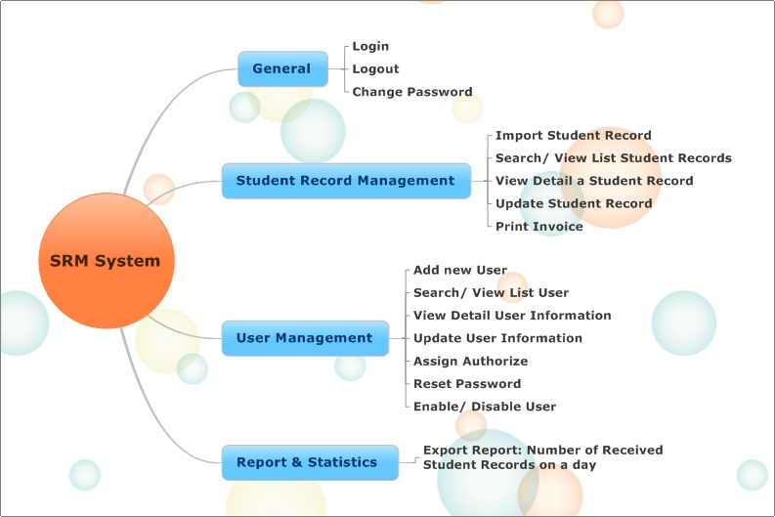

## User classes and characteristics

|  |  |  |
| --- | --- | --- |
| ID | Name | Description |
| E01 | Administrator | * To have full access to the system. * Manage all kind of user account * Import Student Record for School |
| E02 | The Faculty Monitor | * Manage user account works for their faculty * Analysis statistics and report about the number received student records of their faculty * Import Student Record for Faculty |
| E03 | The Received Student Record Officer | * Update student record of their faculty Analysis statistics and report about the number student records that they received |
| E04 | The Training Department Officer | * Import Student Record for School * Analysis statistics and report about the number received student records of school |
| E05 | The Human Resource Department Officer | * Analysis statistics and report about the number received student records of school |
| E06 | The Management Committee | * Analysis statistics and report about the number received student records of school |

## Operating Environment

* **Application server (installed Window service server, Database server)**

|  |  |
| --- | --- |
| Processor | 1 x Intel® Xeon® Processor E5606 (8M Cache, 2.13 GHz, 4.80 GT/s Intel® QPI) |
| Memory | 1 x 2GB DDR3 1333 240-Pin DDR3 ECC RDIMMs/UDIMMs (PC3 10666) |
| Hard Disk | DELL 250GB SATA 7.2K 3.0Gbs 3.5" Enterprise |
| MainBoard | Asus Serverboard Z8NA-D6 |
| Chassis | USP 100-450 |
| RAID Configuration | Intel® ICH10R:6 x SATA2 300MB/s |

* **Client PC**

|  |  |
| --- | --- |
| Operation System | Genuine Windows® 7 Home Basic, |
| Processor | AMD AM3 For Phenom™ II/Athlon™ II Family /Processors |
| Chipset | AMD SB710 |
| Memory | 2 x DIMM Slots Dual Channel DDR3 1066/1333 MHz. Support max 4 GB. |
| Graphics | ATI Radeon HD 3200  Support Micorsoft DirectX 10  Choices: NVIDIA GeForce G210 512MB ATI® 4350 512MB |
| Hard Drive | SATA  3.5" 320G |
| Optical Drive | Blue-ray  DVD Super-multi |
| Expansion Slots | 1 x PCI-e 16x |
| Card Reader | MS/MS Pro/MMC/SD |
| LAN/WLAN | LAN: 10/100/1000 |
| Audio | Azalia 8 Channel  ALC1200 |
| Front Panel | 1 x 4-in-1 Card Reader  1 x Headphone  1 x Microphone  2 x USB 2.0 |
| Rear Panel | 1 x D-sub(VGA) 1 x HDMI 1 x Line-In/Line-Out(Front L/R)/Mic-in 1 x Back Surround LR/Side Surround LR/Center LFE 1 x RJ45 LAN 4 x USB 2.0 |
| Dimension&Weight | 112x366x279 mm (W x H x D)  8.75 Kg |
| Power Supply | Peak 200 W (PFC) |
| Accessories | 1 x Keyboard  1 x Mouse (USB)  1 x Warranty Card  1 x Power Cord |
| Software | PC-Cillin 2010 |
| ASUS Utility | ASUS AI Manager ASUS CrashFree BIOS3 ASUS My Logo2  ASUS EZ Flash2 |

## Design and implement constraints

|  |  |  |
| --- | --- | --- |
| ID | Name | Description-limit |
| 1 | **Language** | English(Us) ( default ) |
| 2 | **Technical** | * C #, MS SQL server, vending machines has to use API supporting C # ASP.NET * MVC 3.0 * Entity Framework |
| 3 | **Design interface** | Design interface for this software must base on interface in this documentation |
| 4 | **Implementation Time** | This system shall be deployed in the next two weeks of school year: completed before 13/8/2012 |

## User Documentation

|  |  |  |  |
| --- | --- | --- | --- |
| ID | Support as | Description | Format standard |
| 1 | Catalog Guide | The catalog is described in detail how to use  Describe the basic features  Artwork clearly and fully | It is formatted as Window Form and it is integrated in Help menu of the SRM product |
| 2 | Online Support | Our team will be online to help the user. |  |

# System Use-case

*Reference SRM_****Use-case_ver0.2*** *appendix was attached*

# External Interface Requirements

*Reference* *External Interface Requirements appendix was attached*

# Other Non- Functional Requirements

## Quality Attribute Ranking Table

|  |  |  |  |
| --- | --- | --- | --- |
| Quality Attribute | Important (base on customer) | Difficult level (to implement) | Priority |
| Security | **High** | **High** | **High** |
| Usability | **High** | **High** | **High** |
| Performance | **Medium** | **High** | **Medium** |
| Availability | **Medium** | **Medium** | **Medium** |

## Performance:

* Scenario ID: QA_P01

The received student record officer update student record while the system is operating normally, the system will update new information into database and notice update successfully within 2 sec

|  |  |
| --- | --- |
| **Portion of scenario** | **Possible values** |
| **Source** | The received student record |
| **Stimulate** | Update student record |
| **Artifact** | System, information in the system |
| **Evironment** | System is operating normally |
| **Respone** | System will update new information into database and notice update successfully |
| **Respone measure** | Within 2 s |

* Scenario ID: QA_P02

The faculty monitor import student record while the system is operating normally, the system will import information into database and notice import successfully within 10 sec

|  |  |
| --- | --- |
| **Portion of scenario** | **Possible values** |
| **Source** | The faculty monitor |
| **Stimulate** | Import student record |
| **Artifact** | System, information in the system |
| **Evironment** | System is operating normally |
| **Respone** | System will import information into database and notice import successfully |
| **Respone measure** | Within 10 s |

## Availability:

* Scenario ID: QA_A01

The faculty monitor sends a request to statistic student record to the system while the system is operation normally, the system will display the information within 5 s

|  |  |
| --- | --- |
| **Portion of scenario** | **Possible values** |
| **Source** | The faculty monitor |
| **Stimulate** | Request to statistic student record |
| **Artifact** | System, information in the system |
| **Evironment** | System is operating normally |
| **Respone** | The system will display the information |
| **Respone measure** | Within 5 s |

## Security

* Scenario ID: QA_S01

Unknown human try to change information in the system while the system is operating normally, system will denying them access

|  |  |
| --- | --- |
| Portion of scenario | Possible values |
| Source | Unknown human |
| Stimulate | Try to change information |
| Artifact | System, information in the system |
| Evironment | System is operating normally |
| Respone | System will denying them access |
| Respone measure |  |

## Usability:

* Scenario ID: QA_U01

The received student record officer, wanting to print invoice quickly, wishes to use the system efficiently. Print invoice take place in less than 5 sec

|  |  |
| --- | --- |
| Portion of scenario | Possible values |
| Source | The received student record officer |
| Stimulate | Wishes to use the system efficiently |
| Artifact | System, information in the system |
| Evironment | System is operating normally |
| Respone | Print invoice quickly |
| Respone measure | Less than 5 s |

## -- The End --